CB.EN.U4CSE22311

1 D ARRAY SET-2

Q1) [Write a C program to display and count of total number of negative elements in an array](https://codeforwin.org/2015/07/c-program-to-count-negative-elements-in-array.html).

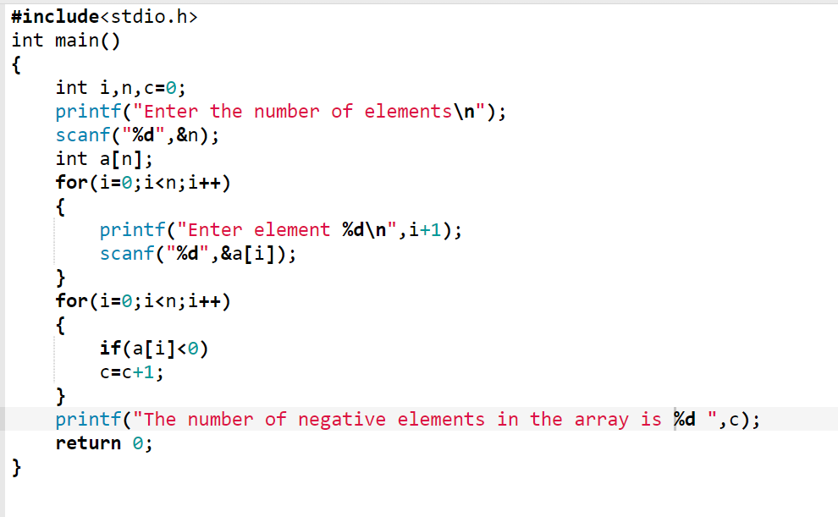

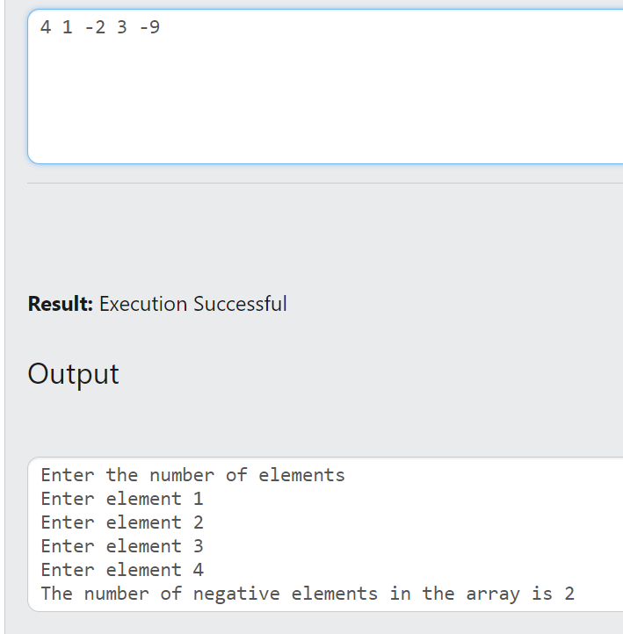

Q2) Write a C program to display the maximum and minimum element of an array.

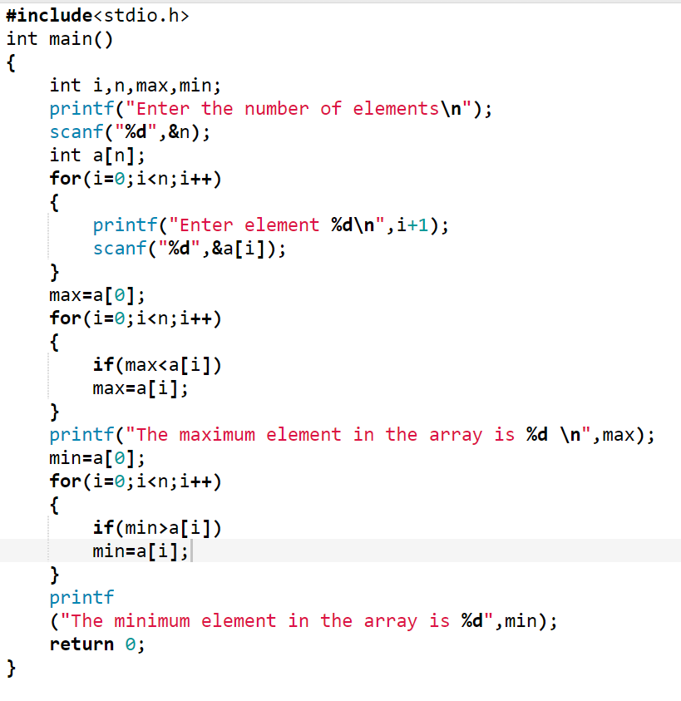

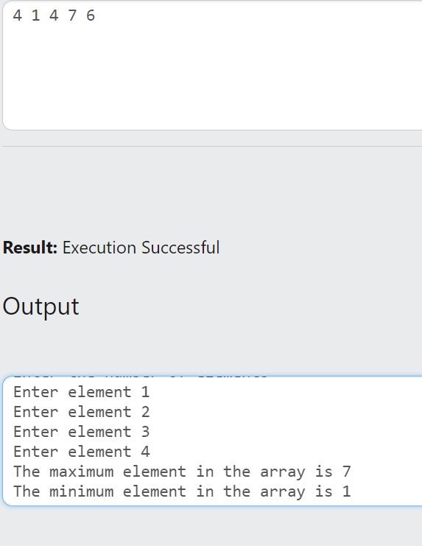

Q3) [Write a C program to insert an element k in the array](https://codeforwin.org/2015/07/c-program-to-insert-element-in-array.html) B at a position p.

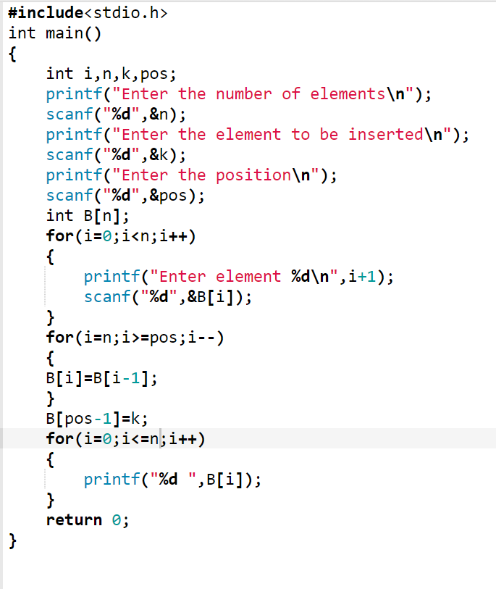

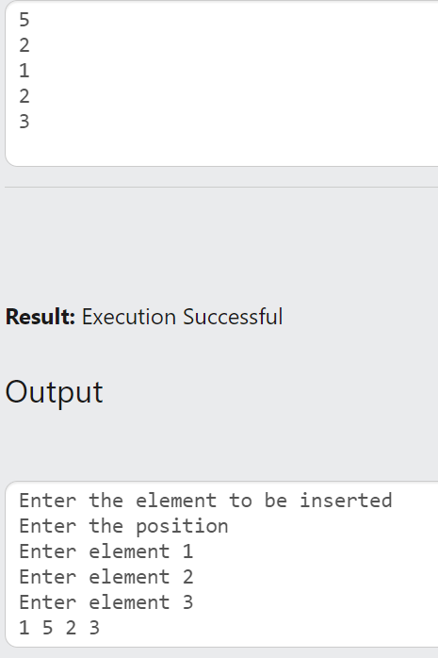

Q4) [Write a C program to delete an element from an array T at a specified position](https://codeforwin.org/2015/07/c-program-to-delete-element-from-array.html) p.

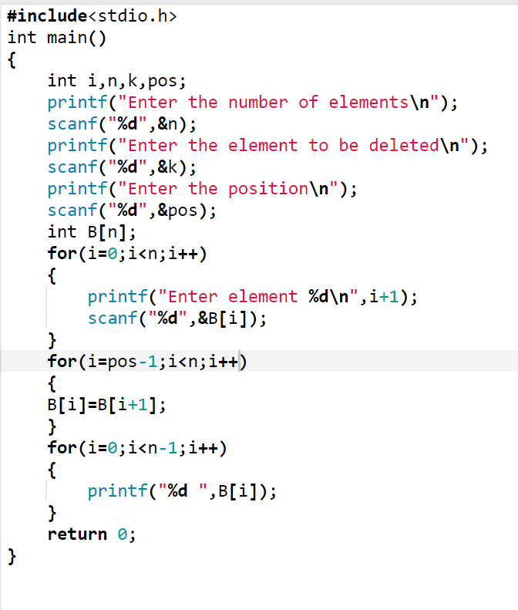

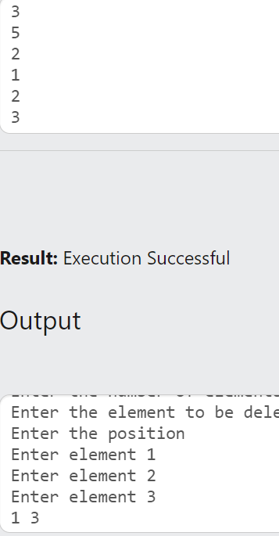

Q5) Write a C program to search an element k in an array A. If element is present display its position, otherwise display “not present”. (Use Linear search)

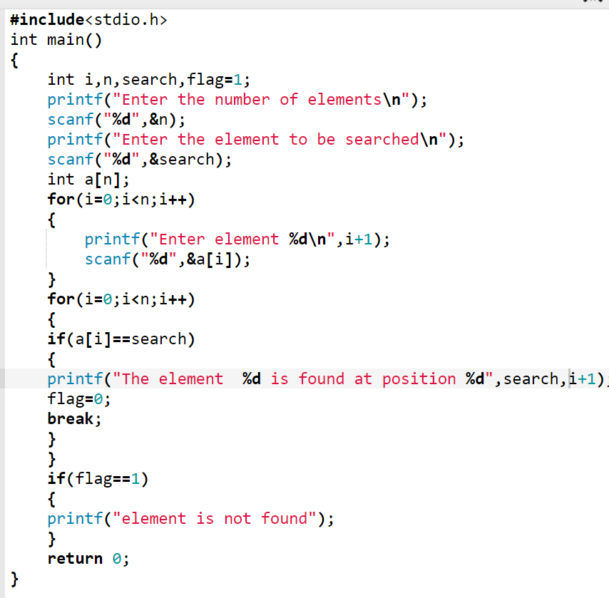

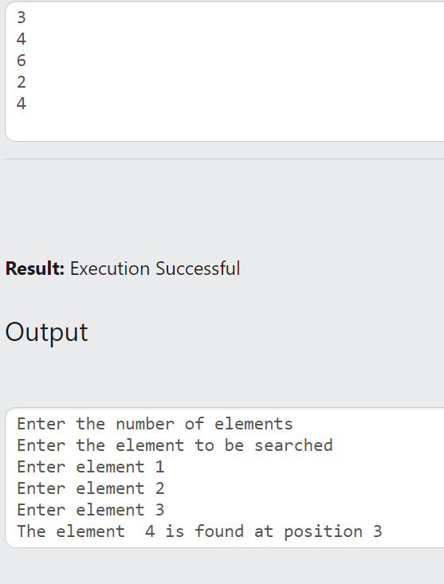

Q6) Write a C program to search an element k in an array A. If element is present display its position, otherwise display “not present”. (Use Binary search)

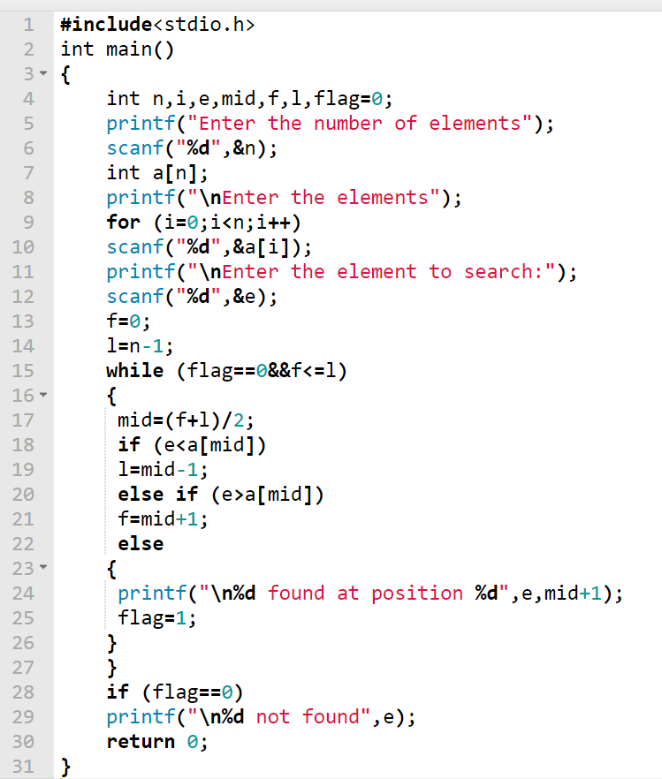

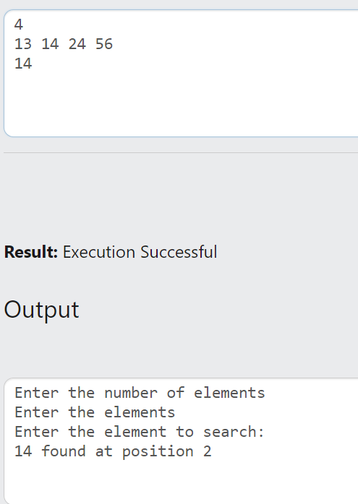

Q7) [Write a C program to count frequency of each element in an array](https://codeforwin.org/2015/07/c-program-to-find-frequency-of-each-element-in-array.html).

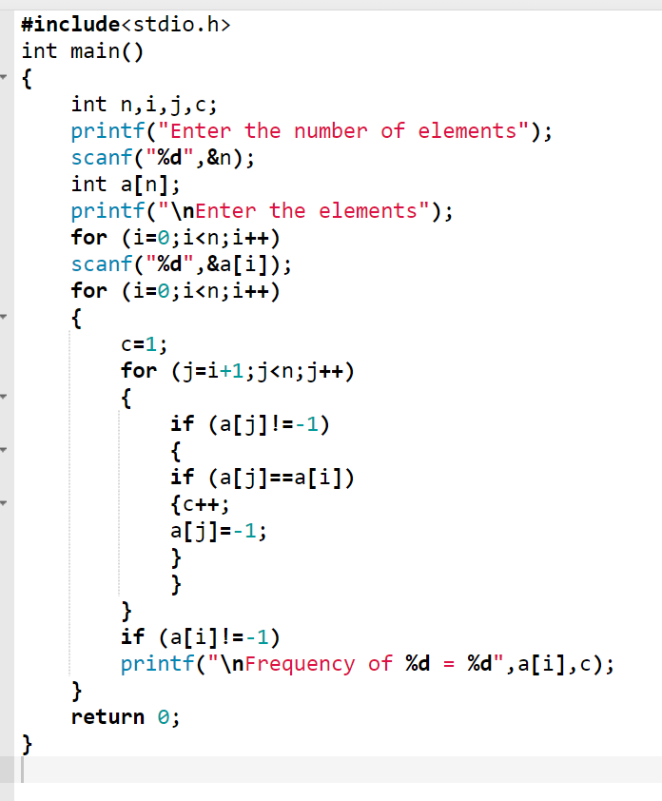

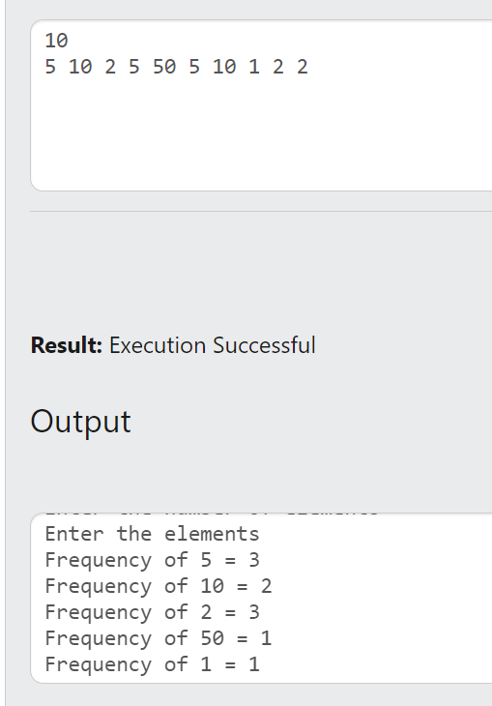

Q8) [Write a C program to print all unique elements in the array](https://codeforwin.org/2015/07/c-program-to-print-all-unique-element-in-array.html).

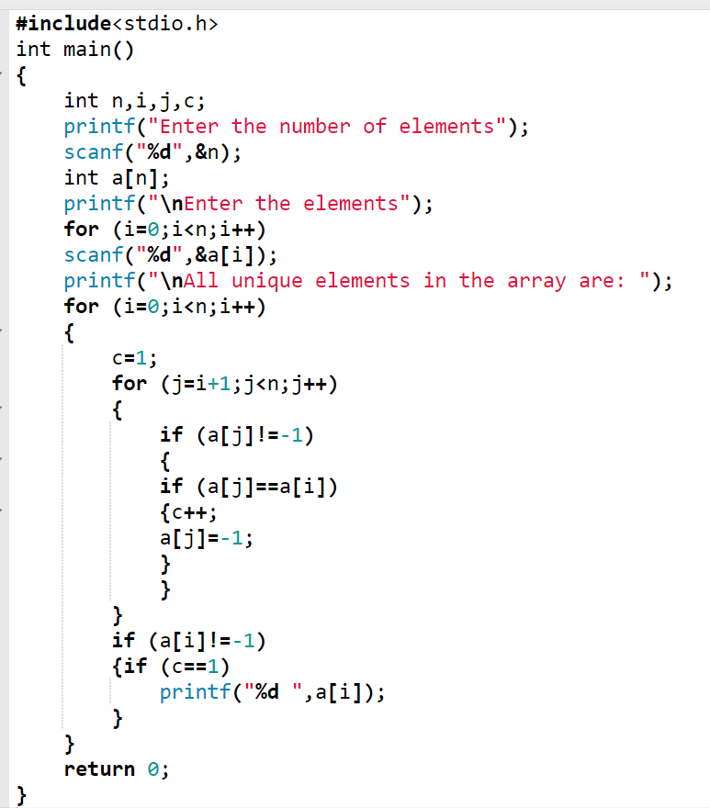

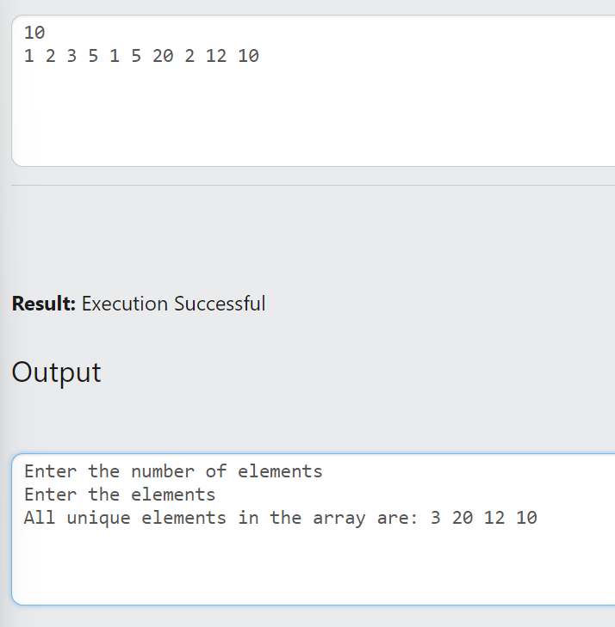

Q9) [Write a C program to find second largest element in an array](https://codeforwin.org/2015/11/c-program-to-find-second-largest-number-in-array.html).

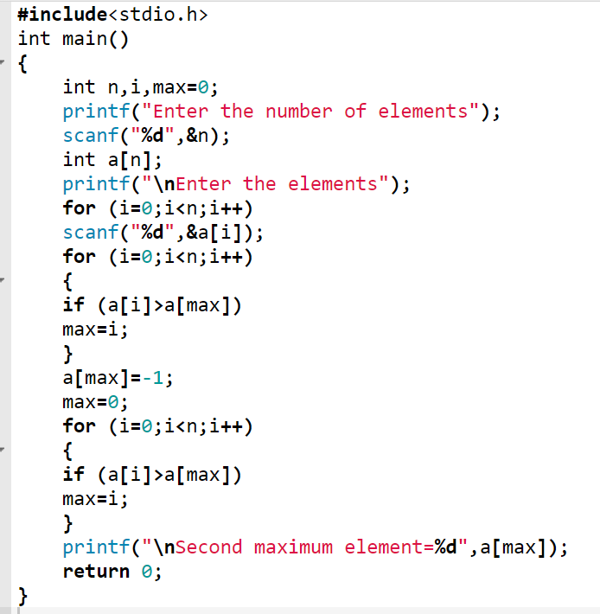

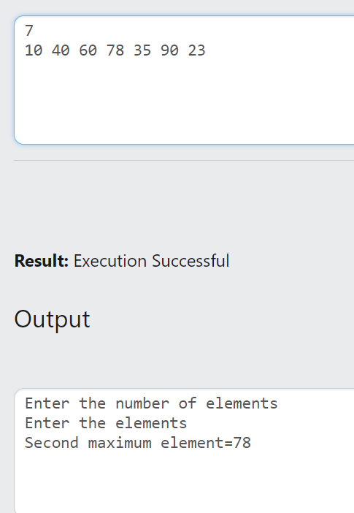

Q10) Write a C program to sort the array in ascending order using bubble sort

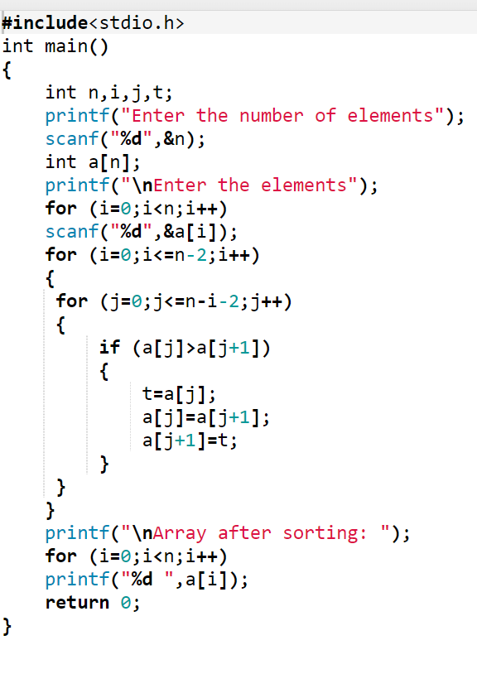

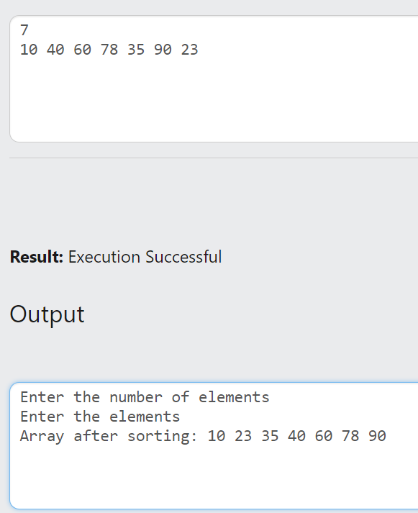

Q11) Write a C program to sort the array in descending order using selection sort

